SD LAB1: SWE

Student name: Mbiydzenyuy Stephen Junior

**Task 1 - Introduction**

1. **Give a brief explanation of the architecture of my intelligent agent solution**

This intelligent agent solution implements a pathfinding simulation using a structured architecture that includes core components such as the Environment class, which manages the grid-based world, and the CellType enum class, which defines various cell states (empty, obstacle, target, agent, path). It features a grid-based environment with customizable dimensions, random obstacle generation, and Pygame-based visualization, supporting various pathfinding algorithms along with agent movement and path tracking. The implementation utilizes Pygame for rendering, employs Queue and PriorityQueue for efficient pathfinding, and allows for dynamic environment updates, all within a modular design that facilitates easy extensions. The main classes include the Environment, which handles the world state and visualization, and CellType, which enumerates the different cell states.

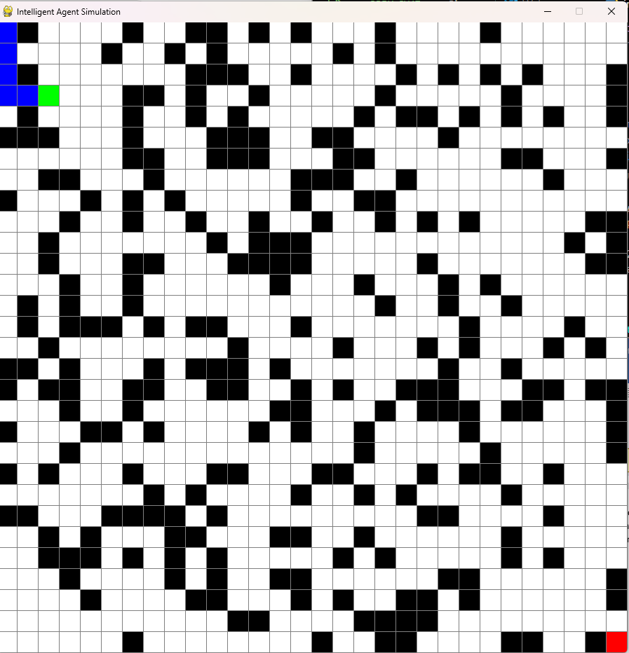

Figure 1: intelligent agent

**b) Advantages and Financial Gains from Intelligent Agents**

**Advantages of Intelligent Agents**:

1. **Trading and Investment**: Enhance algorithmic trading, market analysis, portfolio optimization, and risk management.
2. **Business Process Automation**: Improve customer service through chatbots, automate workflows, and optimize resource scheduling and inventory management.
3. **Data Analysis and Decision Support**: Provide business intelligence, pattern recognition, predictive analytics, and decision optimization.
4. **Security and Monitoring**: Facilitate fraud detection, network security, system monitoring, and threat detection.
5. **Marketing and Sales**: Aid in customer targeting, recommendation systems, lead generation, and campaign optimization.
6. **Energy Management**: Optimize smart grids, resource allocation, consumption prediction, and cost reduction.
7. **Healthcare**: Assist in diagnosis, treatment planning, patient monitoring, and resource scheduling.
8. **Logistics and Supply Chain**: Optimize route planning, inventory forecasting, delivery scheduling, and warehouse management.

**Financial Gains from Intelligent Agents**

* **Increased Efficiency**: Automating tasks reduces labor costs and boosts productivity.
* **Enhanced Decision-Making**: Data-driven insights minimize costly errors.
* **Cost Reduction**: Streamlining processes lowers operational costs.
* **Improved Customer Experience**: Better interactions lead to higher satisfaction and retention.
* **Higher Sales Conversion Rates**: Personalized marketing increases sales.
* **Risk Mitigation**: Better risk management prevents financial losses.
* **Strategic Resource Allocation**: Ensures maximum returns on investments

**COMMANDS USED TO INTALL PACKAGES**

This code sets up the foundation for a grid-based game or simulation by importing necessary libraries and defining the types of cells that can exist in the game world. The following are the commands used to install the packages from the terminal

* Pip install pygame
* Pip install random

Figure 2 Command used to install packages on the terminal

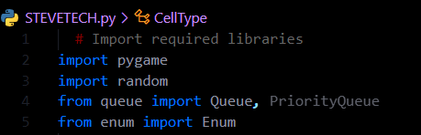The code starts by importing three important libraries: pygame (for creating games and visual displays), random (for generating random numbers), and specific tools from queue and enum libraries that will be used later in the program.

The main purpose of this section is to define different types of cells that can exist in the game grid using a special classification system called CellType. Think of it like creating a legend for a map, where each number represents something specific:

* 0 represents empty spaces
* 1 represents obstacles or walls
* 2 represents the target or goal
* 3 represents the player or agent
* 4 represents the path taken

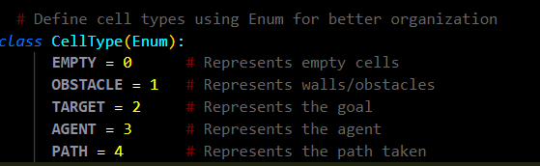

Figure 3 Define cells in the game

This code doesn't take any direct inputs or produce outputs by itself - it's setting up the building blocks that the rest of the program will use. It's similar to defining the rules of a board game before actually playing it.The use of Enum (enumeration) here is clever because it gives meaningful names to numbers, making the code easier to read and understand. Instead of using raw numbers throughout the code, other parts of the program can refer to these cell types by clear names like CellType.EMPTY or 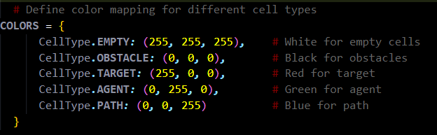CellType.OBSTACLE.

Figure 4 map different cell colors

This foundation will allow the rest of the program to create a grid-based environment where something (likely an agent or player) can move around, avoid obstacles, and try to reach a target. The cell types defined here will be used to track what's in each space of the grid, similar to how each square on a chess board has a specific state (empty, containing a piece, etc.).

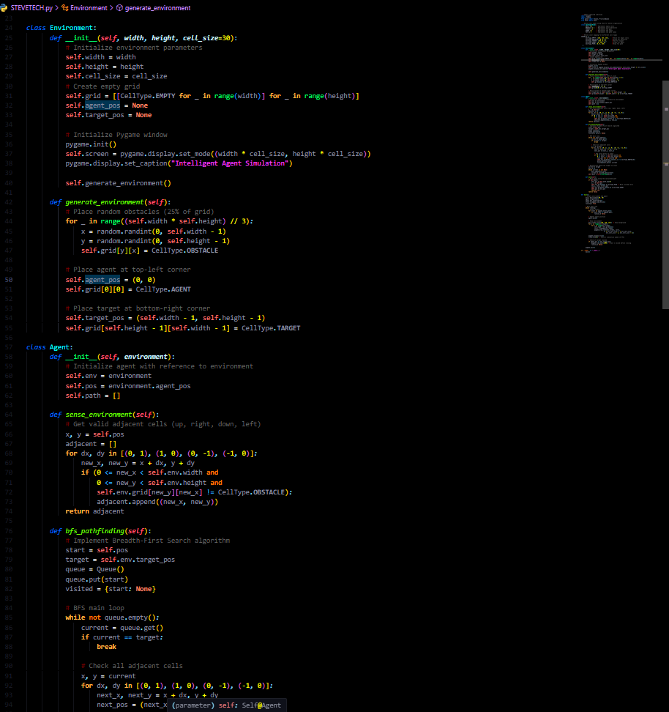

Figure 5 Set the environmentnof the smart agent